Explaining Random Room Generation

My original idea I had for random room generation came from Binding of Isaac, which is a top down game with random elements. The thing about Binding of Isaac is that each stage uses randomly placed templates in a grid for each stage, where monsters are placed in a defined area. So every time you played the game you experienced something different. There’s also a tiny mini map at the top corner of the screen.

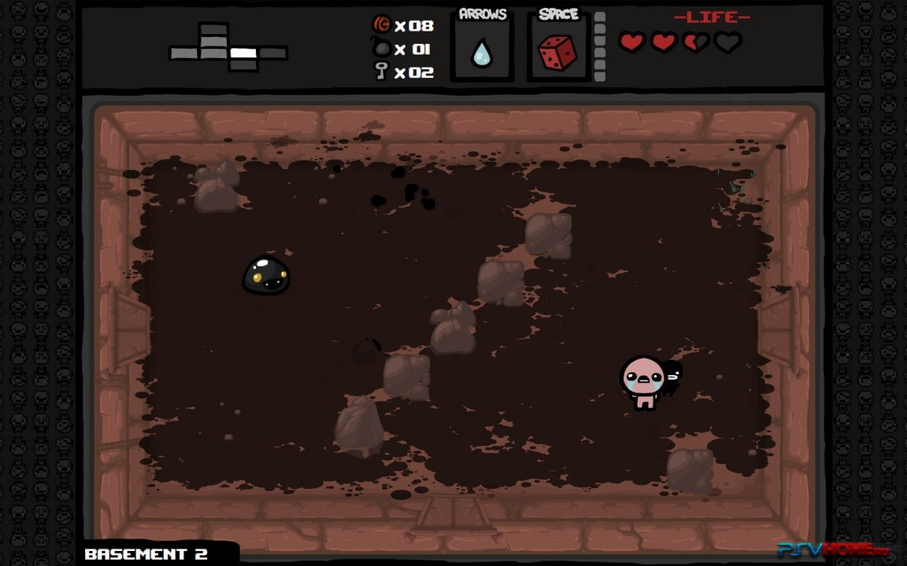

You can see in the top corner of this image is a mini map. This basically shows a top down view of where the player is and where he can go. The white block is where the player is. The grayish block is where the player has been previously. They darkish gray is where the player hasn’t been but can go. I suggest looking at a youtube video of Binding of Isaac to see how it is in action.

But it works, since each stage you begin in a single room. All the areas are the same size so it fits perfectly as a grid and the mini map is a grid also that gives you heads up of where you can go.



I wanted something like this for Stereotype, only for a side scrolling instead of a top down. I created some template levels to be used in a grid type map system. You see there will be four doors. Above the doors are arrows and those arrows show players where the door will lead them on map. There should also be a mini map players can toggle showing the grid, but that can wait for now. It should display items that players left behind, as well as areas that the player is occupying, has recently occupied, and areas that haven’t been seen yet.

I know in programing you need to know what type of rooms have to be generated in each level. For this game the typical lay out is.

1. Start Room
   1. Where the character begins. No enemies are in this room.
2. Shop Room
   1. Where the player can spend Junk and buy items.
3. Item Room
   1. Players get a random item for free.
4. Special Rooms X2
   1. Randomly selected rooms that contain weird stuff
   2. There will be various types of special rooms, each type has a specific door to identify it.
      1. Normal Doors
         1. Represents the typical door.
      2. Locked Doors
         1. These doors require key cards.
         2. Usually Locked Doors lead to treasure rooms.
      3. Broken Doors
         1. These doors require you to blow them up with grenades.
         2. Usually Broken Doors are doors that nowhere (Nowhere meaning rooms that don’t exist on map), but sometimes there is a secret area that may or my not contain something valuable. So a player must choose to blow up doors
      4. DNA Doors
         1. Steals a small amount of HP to open
         2. Contains random treasures with a higher chance of a very rare item.
         3. Since this is a game show I had an idea of ratings and maybe depending on your rating is what special room you will get. So you might get it you might not.
5. Boss Room
   1. Fight the boss and gain an item. Exit door to the next level.

Of course as the game goes on this list can grow and maybe some hidden secrets could be added to this list.

So lets say for example the grid is about 12 by 12. I’m thinking this should give enough diversity in the levels. So at Level 1 the grid map is small but as the game gets harder the map gets bigger.

So I’m not looking at any big levels…especially for this first demo one. I’m hoping that each level takes about 10 min to beat at the very least.

**Encounter Rooms**

When you enter a new room and there are bad guys inside, all the doors lock and they will not open until all enemies are killed.

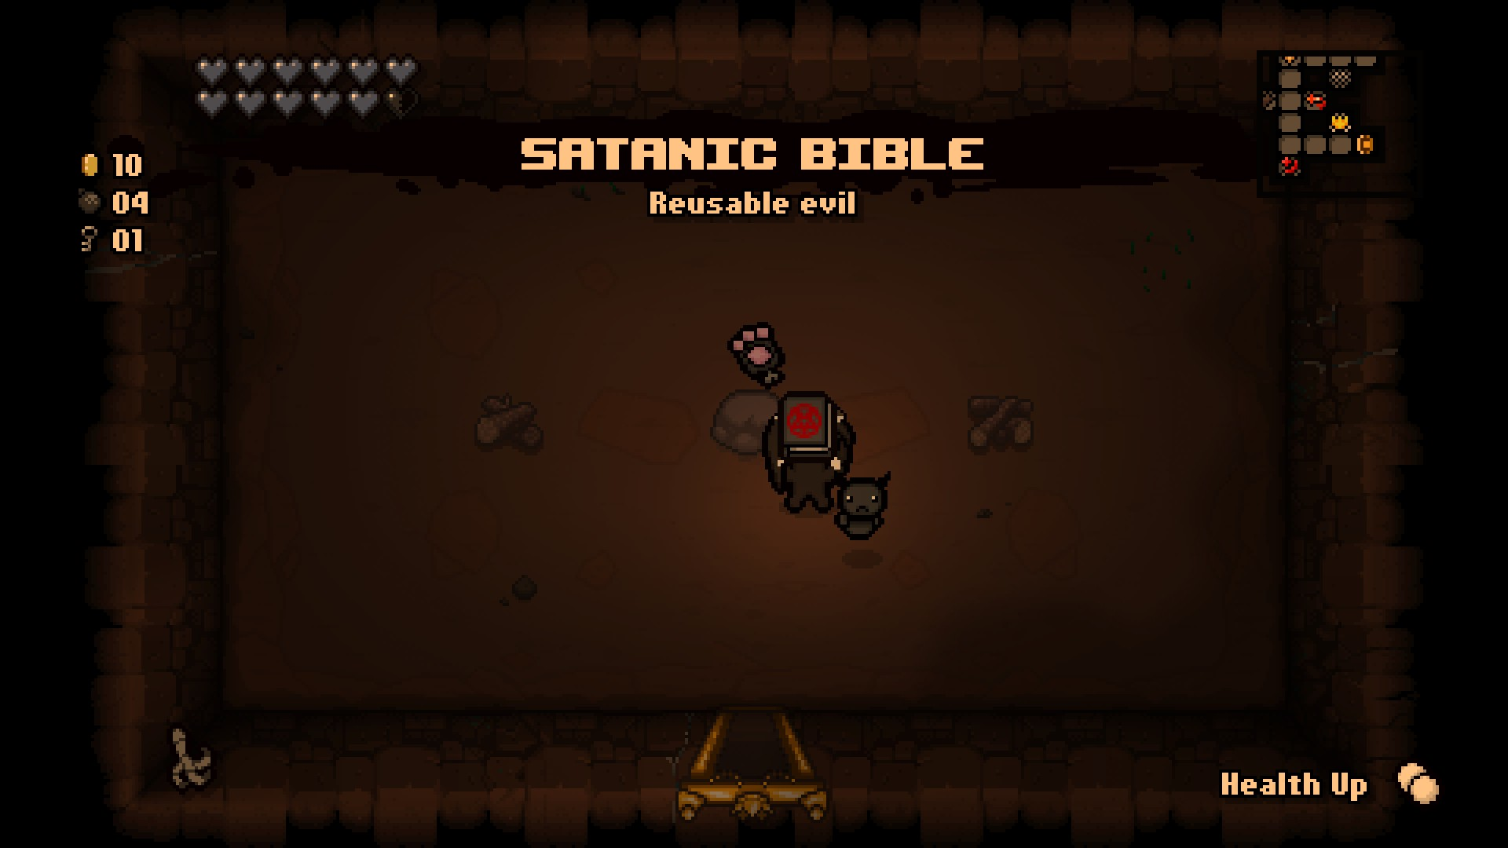

The mini map also displays items that the player left behind in an empty room, or special room types.

Door Type

Depending on the type of room, there are doors that require the player to make certain qualifications. So far there are only 5 types of doors.

1. Normal Doors
   1. Represents the typical door.
2. Locked Doors
   1. These doors require key cards.
   2. Usually Locked Doors lead to treasure rooms.
3. Broken Doors
   1. These doors require you to blow them up with grenades.
   2. Usually Broken Doors are secret areas that may or my not contain something valuable.
4. DNA Doors
   1. Steals a small amount of HP to open
   2. Contains random treasures with a higher chance of a very rare item.

**The entire map**

So here is an example of how the random map should appear on screen from a distance, in the hierarchy. Each block is the area for the stage. One block will be a shop, one block a boss room, etc.

And of course doors will teleport you to its assigned area…

And each time the level is created the various rooms will be randomized around.

If you can picture the scene camera in each block that will teleport to the associated block when a door is used.

The Grid should be large enough to hold any area. I think this can be done with prefab levels. I made a few prefab examples in the prefab folder under, Caverns.

You can see the main levels in the Scene folder > Areas folder > Cavern. 

1. Starting Area
2. Shop
3. Item Room
4. Special Room 1
5. Special Room 2
6. Boss Room

So I hope that makes sense.

I did run into a problem where all the sections of the prefab didn’t appear when you dragged it into the hierarchy. Unless you selected the hidden object individually. It was usually the Fer2d levels.

Again I only made a few, I plan to make a lot more sections for each level. So depending on how you make the generator, can you make it so that I can add levels to it once created.